

SETHEO INVESTMENTS t/a

SETHEO INVESTMENTS

t/a

COMPANY PROFILE

SETHEO ENGINEERING



http://www.csvwater.co.za/imgs/co1.gif

Since its inception SETHEO has grown phenomenally to become a force to reckon with in the Civil, Building, mechanical Engineering and electrical reticulation in South Africa. The company has a strong vision of developing the business into an engineering powerhouse delivering high quality projects in Africa and abroad. The main areas of specialisation are Electrical, Civil and Building Engineering and mechanical

**SETHEO deliver electrical, civil, mechanical, Building and consulting services to a wide range of clients including state and local government, blue chip construction companies, land and property developers and allied professionals.**

SETHEO prides itself on an effective and responsive approach that aims at providing cost-effective outcomes for clients and the community, together with the flexibility to supply dedicated teams for all projects irrespective of size and value. For all projects our approach to service delivery remains the same:

* We place priority in delivering projects on time and within budget.
* We assign dedicated and customer focused teams with skills matched to the project requirements.
* We employ a flexible approach that can be adapted to each client’s specific needs.
* We are outcome driven.

SETHEO is managed and structured to achieve trustworthy and effective results, even to the most challenging client requirements.

This, we believe, forms the foundation for mutually beneficial, long-term partnerships and will ensure that we reach our goal of adding value to our client’s processes.

We endeavour to exceed our clients’ expectations with the solutions we provide.

We aim to price our solutions and services competitively and deliver projects within budget while continuously striving to reduce cost.

SETHEO is organised and structured to form strategic partnerships with the client to make average business better and give them a competitive edge.

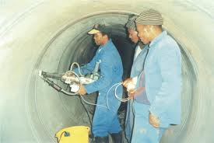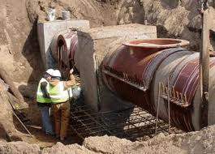

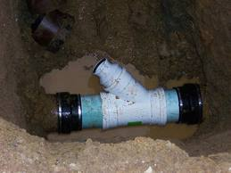

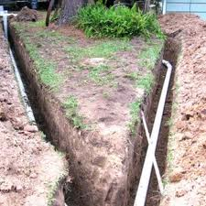

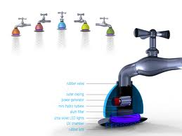

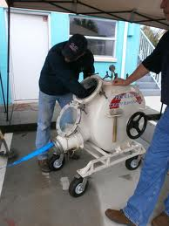**http://t2.gstatic.com/images?q=tbn:ANd9GcR2aKQnIaoZAZXrxTG9ePI8rWSQq4PIdBdC5KGuxqnVHG3S_VKh**

**SEWER AND PIPELINE INSTALLATION**

**Mission Statement**  
Our mission is to provide our employees with an honest and helpful working environment, where every employee individually and collectively, can dedicate themselves to providing our customers with exceptional workmanship, extraordinary service, and professional integrity. Our commitment to this mission will allow SETHEO to become not only a premier construction company, but the premier construction company in Africa

**VISION & VALUES**

**Key Values**

**SETHEO values’ are as follows**

* We believe in high quality workmanship and will go out of our way to achieve that.
* We believe in our stuff and therefore allow them to make critical decisions that have a positive impact on our projects.
* We believe communication is the key in solving problems that may arise during the project delivery process.
* We keep our promises to all our stakeholders because honesty is our hallmark.

**The Vision SETHEO is to be the preferred provider of Electrical, Plumbing, Building, mechanical and Civil engineering. We strive to:**

* Promote a culture of performance thus creating long-term value
* Deliver breakthrough cutting edge technologies and innovative solutions
* Pursue customer service excellence
* Deliver quality work in a sustainable, safe and environmentally responsible manner

**At the core of our values is:**

* Professionalism and excellent workmanship
* Taking responsibility for our actions and honouring our commitments, thus creating accountability
* Building trust through open, honest and consistent interaction

We provide Plumbing Service and Trencheless Sewer Repair to Residential, Commercial, and Industrial facilities.

* Sewer and pipeline repair
* Sewer video inspection
* Water leak detection
* General plumbing
* Drain repair and installation



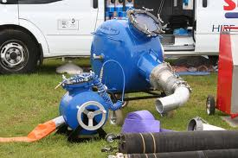

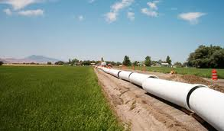



**EXECUTIVE SUMMARY**

**SETHEO** was established a few years back as a general contractor offering construction services in terms of Site Analysis, Feasibility Studies and Preliminary Design Studies.

We handle various industrial, distribution, manufacturing, office; retail, recreational, Plumbing and commercial projects in South Africa.

SETHEO ENGINEERING is an organization that specializes in design, engineering, project management and construction.

We do Tenant Improvements, Design Build, Midrise/High-rise, Retail, Campus-type projects, or state-of-the-art custom facilities

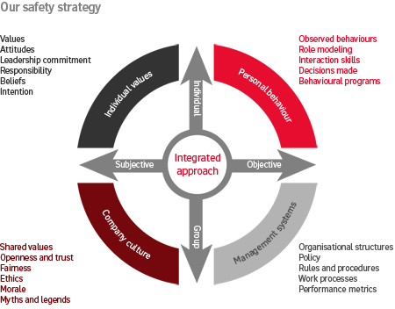

**Quality Policy**

**SETHEO** provides professional service to the client through innovation, Excellence and Quality

**Environmental Policy**

**SETHEO** is committed to conducting business in an environmentally responsible manner, Fulfilling our responsibility to protect the environment enhances our ability to provide competitive and profitable products and services.

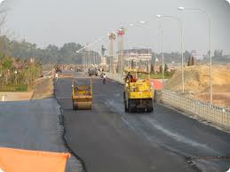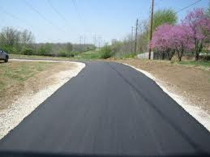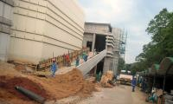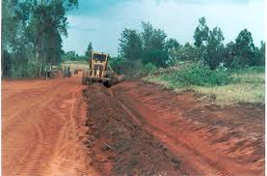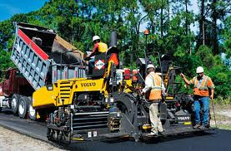

**CIVIL AND ROAD CONSTRUCTION**

**ELECTRICAL ENGINEERING DIVISION**



**HIGH VOLTAGE TRANSMISSION AND DISTRIBUTION**

High voltage line construction is a technical process due to the specialized equipment and skills required to deliver such a project. Setheo has acquired most of its equipment required in the erection of power line towers and stringing of conductors.

This has enabled us to complete projects faster and to guarantee excellent quality to our Clients.

**MEDIUM TO HIGH VOLTAGE SUBTATION**

Setheo has constructed numerous substations in South Africa. We have successfully completed electrification projects in Mpumalanga, Gauteng and Eastern Cape.

The company has upheld the highest standards of safety and workmanship during and after completion of these projects.

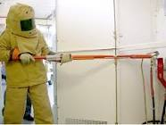 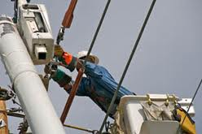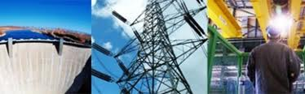

Due to global warming and other pressing environmental issues, renewable energy resources have become critical to the survival of the planet. Solar, wind and water are now the preferred sources of power as opposed to the use of carbon based fuels. Setheo has formed strategic alliances with companies from Israel and China which supply the company with equipment and technology such as solar panels, solar water heaters and PV systems components. We partnered with several specialists in renewable energy.

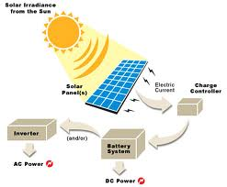

**RENEWABLE ENERGY PROJECTS**

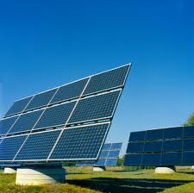

**STREET LIGHTING**

Setheo engineering specializes in the installation and maintenance of street lighting for urban settlements. The company has carried out projects in Johannesburg, Ekurhuleni, Eastern Cape, Mpumalanga and other municipalities where it has installed new street lighting. Setheo has acquired critical equipment such as Augers and Cherry pickers required for the installation and maintenance of such projects. This has enabled the company to operate more efficiently and reduce labour based costs

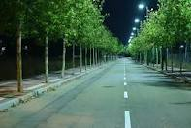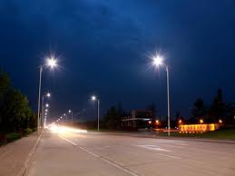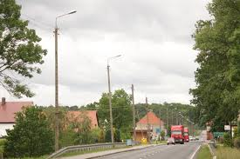

**MECHANICAL ENGINEERING DIVISION**

**KEY SERVICES**

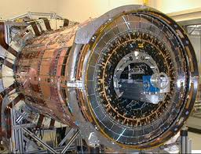

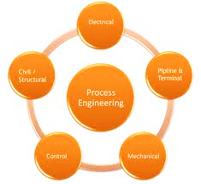

* **Boiler Making Solutions**
* **Water Treatment Plants**
* **Chillers Plant maintenance**
* **Water Purifying Chemicals**
* **Power Machine**
* **Electric Power Stations**
* **Power Machines**
* **Central Energy Plant**

**.**



**MECHANICAL ENGINEERING DIVISION**

**Civil and buildings division specializes in the following areas**

**Civil/Roads Division**

* Urban Development and Management
* Telkom Trenching
* Roads and Bridges
* Township Infrastructure
* Residential Townships
* Civil Engineering Services and Site Works for Building Projects

**CIVIL AND BUILDING ENGINEERING**

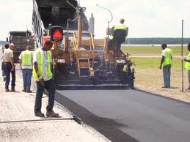

We are now serving a variety of premises and facilities such as:

* Commercial buildings and factories
* Shopping Malls
* Supermarkets
* Restaurants \***KITCHEN EXHAUST SYSTEM**
* Movie Production Studios
* Residential Buildings
* Private Properties
* Industrial, Commercial and Residential Demolition
* Bulk Excavations and Site Clearance
* Listing Building Dismantlement
* Facade Retention
* Reclamation and Recycling of Waste and Scrap
* Associated Building and Refurbishment Work
* Dismantling Steel Structures
* Asbestos Removal
* Site clearance

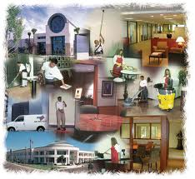

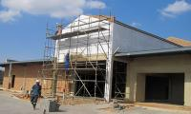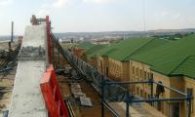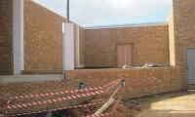

**CIVIL AND BUILDING ENGINEERING**

**Water Engineering Division**





* **Bulk Water Supply**
* **Storm water Management**
* **Sewerage Trunk Sewers, Reticulation, Pump stations**
* **Roads, Stormwater Drainage, Sewers and Water Supply**
* **Water Supply**
* **Wastewater Treatment**
* **Polluted Stormwater Control**
* **Stormwater Drainage Modelling**

**Building Infrastructure-Industries-Civil-Electrical & Mechanical Engineering Services**

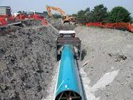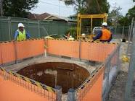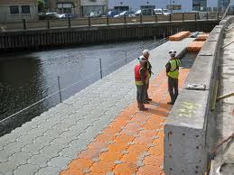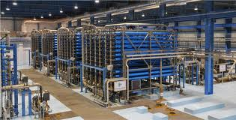

**SETHEO ENGINEERING**

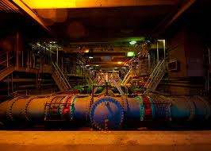

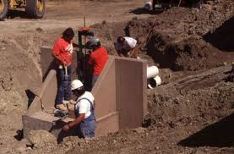

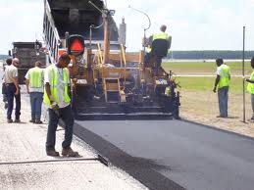



**CIVILS Consultation services**

**Services offered**

* Design and processing of roads, sewers, storm drain, water, and utility improvement plans;
* land planning design and all processing functions adjustments, zone changes, conditional use permits and variances;
* And all field surveys for architectural, topographic, encroachments and plot maps needed in the processing of land development.

* Commercial Buildings
* Residential Buildings
* Civil Structures
* Hospitals
* Educational Facilities
* Recreational Facilities
* Financial Institution
* Retail Complexes
* Affordable Housing

**Buildings/Structural Engineering**

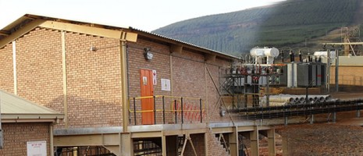

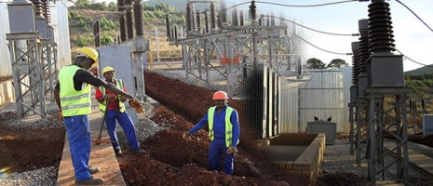

***ELECTRICAL DIVISION***

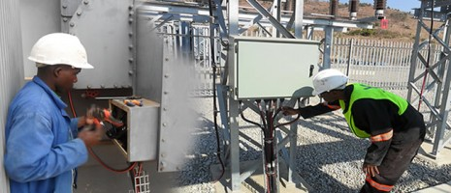

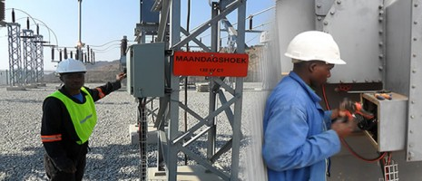



SETHEO a division of SETHEO INVESTMENTS which has interests in the following sectors

* Civil & Building Engineering
* Electrical reticulation
* Telecommunications cabling
* Energy Resources
* Mechanical Engineering

**BUSINESS OWNERSHIP**

***KEY Personnel***

**BRIDGET SHUMBA** NON-EXECUTIVE DIRECTOR

Bridgette is an accomplished business woman with vast experience in business administration and computer programming. She is a holder of Computer programming and business administration diploma.

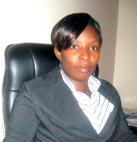

**T. Mangwana (MBL)** Managing Director

He is an inspirational entrepreneur who has built a strong business empire from very small beginnings.

He sits on boards of several companies and is the man behind Setheo`s strong vision. He is a holder of an MBL degree from Unisa, and a diploma in electrical engineering from City and Guilds of London.





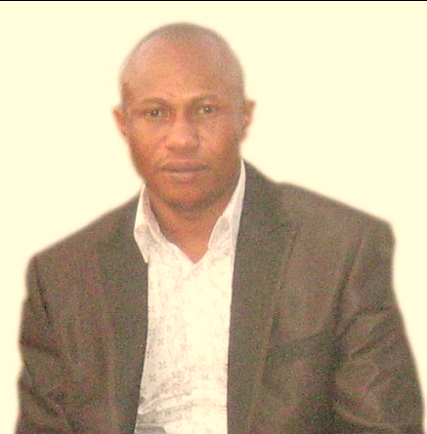 

**ADELIA FANI** PROJECT COORDINATOR

Adelia is an innovative Business Analyst who has started off as a Software Developer in 2001. She holds a BCom Degree in Informatics from UNISA and has vast clientele experience. She is the force behind Setheo`s Business Processes, Business Re- engineering, Clientele Management and System Technology. Adel’s vast experience Business Systems management uniquely places Setheo Holdings above its competitors

**BEVEN MOODLEY** FINANCIAL DIRECTOR (**GRAD ICSA (ACIS**)

Beven started his career in the financial field in 1991. He has gained vast experience in the finance and businessadministration field in several businesses, which include public entities of chartered secretaries and administrators and currently holds an Associate membershipstatus at this prestigious professional institute. Beven is in his final year studying to be a Graduate at the Association of CharteredCertified Accountants (CCA)

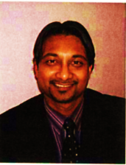

## CORNELIUS SCHWATS OPERATIONS DIRECTOR An Electrical Engineer who is the operations director; from WITS University- RSA, completing his E.Eng-ELECTRICAL at WITS University- RSA, He has worked on several projects in South Africa(City power & Eskom) and has various experience in the Electrical Industry especially in the Power Distribution and Conversion system as he participated in many Projects within Eskom : -Replacement of Harmonic Filters in the Conversion Station, Power Transformers up to 120MVA in the AC Yard-SCI, Replacement and Refurbishment of Various Types of Switch-Gear, Synchronous Compensators etc... Experienced in LV, MV and HV Power Lines Construction and Maintenance including Voltages ranging from 400V, 6,6KV, 11KV, 22KV, 66KV, 132KV & 220KV - participated in the maintenance of INGA-KOLWEZI HVDC Power line (220KV-DC) has also worked on Substation construction and Maintenance up to 120MVA. - Industrial Automation - Building Reticulation and Installations - Designing, Inspection and Commissioning of Installations

**MAKHAYE MBOMBI DILUBENZI** (CHIEF ENGINEER) An Electrical Engineer who is the Marketing director; from ISTA Ndolo- DRC, completing his M.Eng-GDE Mechanical at WITS University- RSA, He has worked on several projects in SNEL(Power Utility DRC) and has various experience in the Electrical Industry especially in the Power Distribution and Conversion system as he participated in many Projects in INGA Power Plant like : -Replacement of Harmonic Filters in the Conversion Station, Power Transformers up to 120MVA in the AC Yard-SCI, Replacement and Refurbishment of Various Types of Switch-Gear, Synchronous Compensators etc

***EXPERIENCE***



SETHEO is made up of an appropriate number of permanent professional and support staff of varying qualifications and experienced, Electrical Engineers, Civil Engineers plumbing Engineers ,Mechanical engineers, Consultants, Health & Safety officers, First Aiders, Systems Analysts and Technical handymen right through to clerks ready to be deployed for assignments nationally and regionally at the shortest notice.

We have on our database a substantial number of independent consultants with whom we cooperate with on a project-by-project basis.

**SETHEO ENVIRONMETAL HEALTH & SAFETY**





SETHEO strives to create a safe working environment for its employees. Safety is rated well above all other aspects of our operations. We have taken a deliberate stance to have a continuous improvement policy for our working methods in order to address the ergonomic challenges arising thereof. Management and field employees undergo extensive and continuous training on safety.

As part of our corporate social responsibility, we have adopted a life cycle management approach in our operations to ensure a sustainable built environment. The company has deployed health and safety inspectors who conduct a day to day safety meeting with employees.



***CONCLUSION***

Here at SETHEO there is no more important goal for each of us than the achievement of high standards of service to our client.

The pursuit of excellence is not an option for us but more of a business necessity.

**CONTACT DETAILS**



**22 Richards drive**

**Halfway house**

**Midrand**

**Johannesburg**

**South Africa**

## 

**Tel: +27 11 312 9860**

**+27 11 312 9718**

**+27 11 312 3628**

**Mobile: +27 79 079 9069**

**+27 82 582 9227**

[info@setheoholdings.com](mailto:info@setheoholdings.com)

**[www.setheoholdings.com](http://www.setheoholdings.com)**